**Brooklyn torah gazette**

**For parshas behar-bechukosai 5783**

Volume 7, Issue 34 (Whole Number 341) 22 Iyar 5783/ May 13, 2023

**Printed L’illuy nishmas Nechama bas R’ Noach, a”h**

For a free subscription, please forward your request to [***keren18@juno.com***](mailto:keren18@juno.com)

**Would You Give Away Your Bread in a Concentration Camp?**

**By Rabbi Dovid Campbell**

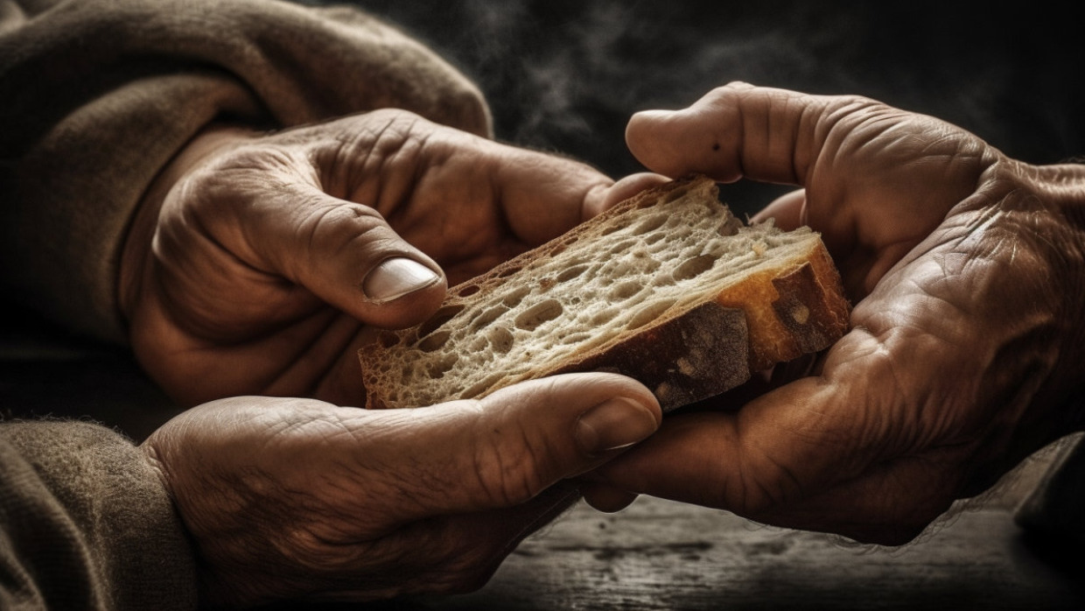

Life in the concentration camps was inherently dehumanizing. The work was crippling, the hunger was unimaginable and the threat of death was constant. Under these conditions, it was difficult to focus on anything but survival. The young [Rabbi Gershon Liebman](https://www.ijn.com/silences-speak-loudly-words-echo-softly/), who would eventually become a powerful force for Jewish education in postwar Europe, quickly recognized the great need to preserve his sense of humanity.

Throughout his time in the camps, he maintained the practice of never eating his entire meal at once, always leaving some food on the plate. This simple action reminded him that he could still behave with refinement and moderation, even here. In a place where people swallowed whatever food they could find, as quickly as they could find it, it seemed absurd to bother with something like this. But Rabbi Liebman refused to be dragged down by external circumstances, no matter how hellish they were.

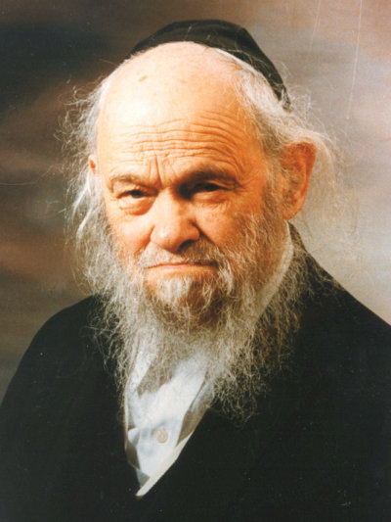

**Rabbi Gershon Liebman, of blessed memory.**

A similar story is told by Rabbi Yaakov Galinsky, who survived the Soviet labor camps in Siberia. Early one morning before the other prisoners were awake, Rabbi Galinsky awoke to a strange sight – an older Lithuanian prisoner was quietly donning a military uniform that he had hidden in a work satchel. Complete with impressive ribbons and medals, it was the full-dress uniform of a Lithuanian general. He began to quietly bark orders and salute the air. He returned the uniform to his satchel when the other prisoners began to wake.

Rabbi Galinsky couldn’t contain his curiosity. The Lithuanian was initially embarrassed to have been seen, but he eventually explained: He had been a general in the Lithuanian army, a decorated military hero with tens of thousands of soldiers under his command. Then the Soviets came and it had all disappeared in an instant.

“They sent me here into exile, to this miserable hole, and they’re doing everything they can to turn me into a wretched prisoner so that I’ll forget my former glory. But I don’t intend to forget!”

**Bottom of Form**

Rabbi Galinsky absorbed a powerful lesson from these words – the same one Rabbi Liebman embodied with his small plate. Circumstances might rob us our comfort, our glory, or even our basic human necessities, but no circumstance defines our self-worth. We can always remind ourselves of who we are, using the mirror of our own proper conduct.

**Pass the Bread**

Rabbi Liebman would often share his bread with other prisoners, nursing them back to health from the brink of starvation. It’s difficult for us to understand what an enormous sacrifice this was. Imagine a patient suffering from pneumonia, struggling to fill his lungs with air, who nevertheless chooses to share his oxygen tank with others. The small daily ration of bread was their tenuous link to life.



**Howard Schultz, left and Rabbi Noson Tzvi Finkel**

Howard Schultz, CEO of Starbucks, recounts an unlikely encounter he had with Rabbi Noson Tzvi Finkel, the head of the Mir Yeshiva seminary. Rabbi Finkel wanted to convey the Holocaust’s enduring lesson for our times, and he did so by portraying the Jewish prisoners’ first night in the camps:

“As they went into the area to sleep, only one person was given a blanket for every six. The person who received the blanket, when he went to bed, had to decide, ‘Am I going to push the blanket to the five other people who did not get one, or am I going to pull it toward myself to stay warm?’ It was during this defining moment that we learned the power of the human spirit, because we pushed the blanket to five others.”

As Rabbi Finkel concluded his meeting with Mr. Schultz, he told him, “Take your blanket. Take it back to America and push it to five other people.”

In the midst of unimaginable hardship, when we would expect individuals to be at their most selfish and cruel, we discover what we are truly made of. Rabbi Liebman took himself out of the picture and focused on the needs of others.

**Find a Reason to Try**

In the Buchenwald concentration camp, it was not unusual for the prisoners to succumb to starvation and exhaustion. The Nazis would place their bodies in a designated room until they could be buried the next day. But Rabbi Liebman suspected that some of these poor souls were not actually dead. Risking his life, he crept into the pitch-black room at night and, crawling among the bodies, searched for signs of life.

Sometimes he would feel warmth in a body, awaken the man, and help him back to his barracks. On one occasion, a body seemed totally dead, but Rabbi Liebman felt a small tremble in the man’s lip. Not knowing the man’s barracks, he brought him back to his own, where he massaged the man back to consciousness. But he was still too sick to be moved and this created a terrifying problem.

Officially the man would be listed as dead, and there were now the wrong number of prisoners in the barracks. Additionally, he would no longer receive food rations. Rabbi Liebman and the other prisoners chose to hide him and feed him from their own meager rations. The man survived and was eventually reunited with his wife after the war.

There were so many reasons *not* to attempt these nightly rescue missions, but Rabbi Liebman was looking for the opposite: He wanted an excuse to try, and he found it in even the smallest tremble of life.

Whether saving a single soul or pioneering Jewish education after the Holocaust, Rabbi Gershon Liebman embodied the beautiful words of Anne Frank: “How wonderful it is that nobody need wait a single moment before starting to improve the world.”

*Reprinted from the May 7, 2023 website of aish.com*

**One of the Most Difficult Mitzvot and G-d’s Desire for Our Trust**

**From the Teachings of the Lubavitcher Rebbe**

**Rabbi Menachem Mendel Schneerson, Zt”l**



This week, we read the Torah portion of Behar. In Behar we learn about the commandment of Shemita, the Sabbatical year. “Six years you should sow your fields..., and gather its produce. And in the seventh year, the land must be given a complete rest, a Sabbatical for G-d, you may not sow your fields...”

This is one of the most difficult mitzvot (commandments), because if all of Israel refrains from sowing their fields, what will everyone eat?

In answer to this question, G-d says, “I will command my blessing for you in the sixth year, and it will yield (enough) produce for three years.” For the end of the sixth year, the whole seventh, and until after the harvest of the eighth year.

**First Temple Era Failures**

Still, we find that this mitzva is so difficult, that during the First Temple era, 70 Sabbatical years were not kept properly. Because of this, after the destruction of the first Temple, we were in exile for 70 years. It is obvious that this mitzva is very important and that keeping this mitzva is crucial to bringing Moshiach.

By taking a look at what is at the core of this mitzva, everything becomes clear. What is at the essence of this mitzva?

We all have a relationship with G-d. For some of us it is weak, for others it is stronger, and yet for some, it is one of rejection. Many of us run the gamut, a roller coaster ride relationship with G-d.

What G-d wants most from us, is that we trust in Him. And this is, what is at the core of this mitzva. Trust is stronger than belief, and we are tested regularly by G-d to see if we put our trust in Him.

Yet it is hard to trust in any person or even ourselves for that matter. How often do we watch ourselves fail at what we set out to do? How often are our hopes dashed, only to find ourselves hurt and broken? We have trust issues.

When it comes to G-d, we need to take a different approach. Because in Him we truly can trust, and the more we get to know Him, the stronger our trust in Him becomes. You come to realize that He is the only one you can actually trust in.

G-d takes care of us. This becomes clear in the sixth year of the Sabbatical, when one would think the field has been drained of its nutrients, due to five years of sowing and reaping. When the sixth comes, there is nothing left for the field to give. It is our trust in G-d alone, that make our fields yield three times their normal produce.

The same is true for Jewish parents. You give, and give, and give, until you feel there is nothing left to give. It is your relationship with G-d, your trust alone, that gives you the strength you never would have imagined you had.

It is my hope that through our building our trust relationship with G-d, we will merit the coming of Moshiach very soon.

Adapted by Rabbi Yitzi Hurwitz from the teachings of the Rebbe, yitzihurwitz.blogspot.com. Rabbi Hurwitz, who is battling ALS, and his wife Dina, are emissaries of the Rebbe in Temecula, CA.

*Reprinted from the Parshat Behar 5783/2022 edition of L’Chaim (Issue #1723), a publication of the Lubavitch Youth Organization in Brooklyn, NY.*

*\*\*\*\*\*\*\*\*\*\*\*\*\*\*\*\*\*\*\*\*\*\*\*\*\*\*\*\*\*\*\*\*\*\*\*\*\*\*\*\*\*\*\*\*\*\*\*\*\*\*\*\*\*\*\*\*\*\*\*\*\*\*\*\*\*\**

*If your brother becomes destitute and his hand falters beside you, you shall support him [whether] a convert or a resident, so that he can live with you.(*Lev. 25:35)

A “sojourner” is defined as anyone who renounces idolatry. This teaches, said the Baal Shem Tov, that even if this is a person’s only merit he is worthy of G-d’s sustenance and eternal salvation. For the children of Israel are servants to Me.

*Reprinted from the Parshat Behar 5783/2022 edition of L’Chaim*

**Rabbi Berel Wein on Parshat B’har-Bechukotai 5783**



These two *parshiyo*t together form the final bookend of the book of *Vayikra*. This conclusion of *Vayikra* is a rather somber one, with the dominant theme being the prediction of Jewish dereliction from Torah values and practices and the resultant exile from their land and sovereignty. Yet in these *parshiyot* there are also promises of prosperity and well-being and successful Jewish life.

The Torah generally conforms to such a pattern of great blessings and stern warnings. It really allows the Jews very little middle ground in which to maneuver the private and national lives of Israel. Our entire history is one of great vacillation between exalted and miraculous moments and dire events.

This certainly is true regarding the story of the Jewish people and the Jewish State over the past century. Our tears are always mixed with joy and our joy is always laden with a heavy dose of accompanying tears. The Torah’s message to us is that life constantly presents different emotions and scenarios that are rarely if ever completely positive or completely negative.

Perhaps this is one of the meanings of the words of the rabbis of the Talmud that everything that Heaven does has good within it. Even if the general event may be deemed to be a negative one, there always is a kernel of good buried within it. So, our *parshiyot*reflect this duality of blessing and accomplishment as well as of defeat and hardship.

This duality also applies to our daily dealings with others. Always try to see the good lurking within another person whenever possible – though I admit that there are situations that make it look impossible to do so. This has always been a premier Jewish trait. The rabbis in *Avot*taught us that every person has his moment so to speak. Seizing and exploiting that moment is the main accomplishment.

But that requires a sense of realism. We cannot fool ourselves into thinking that everything is always correct and well with ourselves and our society, nor can we be so pessimistic and down on the situation that it precludes honest attempts at improvement. The balance of hope and warning that these concluding *parshiyot* of *Vayikra*exude is an important lesson and guidepost.

This lesson lies embedded in another teaching of the rabbis in *Avot:*“It is not incumbent upon you to complete the entire task at hand, but neither are you free to discard it entirely.” Reality dictates to us that we face our world and its dangers squarely and honestly. But we should not abandon hope and the effort to improve our lot.

We believe that positive effort and wise decisions, coupled with faith and tradition allow us to survive and prosper. Therefore, at the conclusion of the public reading of these mixed messages at the end of the book of *Vayikra* we rise and strengthen ourselves “*Chazak chazak v’nitchzeik*.”

*Reprinted from the current website of rabbiwein.com*

******************************************************************

The Jewish people is likened to a single body, with all the corresponding physical components and organs: head, heart, etc. Just as when there is pain in one limb the entire body suffers, so too should every Jew experience the pain of his fellow, and take steps to alleviate it. If you see someone floundering in the mud, the only way to help him is to jump down and pull him up. To help a fellow Jew, we must be willing to sink down into the mud up till our neck. (Rabbi Shlomo of Karlin)

*Reprinted from the Parshat Behar 5783/2022 edition of L’Chaim*

**Rav Avigdor Miller on the**

**Solutions for Sadness**



**QUESTION:** How does one keep from being depressed during times of trouble?

**ANSWER:** Now that’s a general question and it’s like somebody who comes to a physician and says, “How can I be well?” You have to tell him first what you’re suffering from and you have to tell him in detail. And after he thinks of the symptoms and he studies your case, he may be able to help you.

But since it’s a general question we’ll say a general answer.

There are so many positive things in life that a depressed person should consider, thoughts that if you’ll concentrate on them you’ll begin to see how fortunate you are.

But we’ll just give one suggestion. The first thing to do if you’re depressed is to go to a cemetery. And stand outside and think who is better off. Or take a walk on Coney Island Avenue and you’ll pass three funeral parlors within a half hour. They call them funeral homes so you might think that inside, their customers are going to remain there for the next fifty years. It’s a home so maybe they serve them meals, and their children will visit them there. No, no, it’s not that kind of home. So as you pass by think, who is better off?

Look at the blue sky. You know they’re all low buildings, the funeral homes on Coney Island Avenue, and you can look at the blue sky over them. And so you look at the funeral home and then you look at the beautiful sky. If you walk by or you drive by, take a look at the big blue expanse of sky overhead. You can look at it and see it and enjoy it. What are you depressed about? The ones in the home, they should be depressed. They can’t enjoy the blue sky anymore.

**The Man in a Wheelchair**

If you wish, I’ll give you the address of a man who comes out of his house every morning; somebody wheels him out in a wheelchair. And he has a blanket over his lap. Sometimes the blanket is raised up and you see there are no feet. He doesn’t have any feet at all. And then look at your two legs. Let’s say you have arthritic legs, okay. But you want to exchange your arthritic legs for his?

And therefore, depressed people should undertake a course of study and see those who don’t have what they have and you’ll see that your depression is actually nothing. It’s a minor matter, and it’s really silly. In fact, you should be so happy that you should dance for joy.

This Shabbos I was saying in the shul that for those who are depressed we should invite twenty of these people into the shul to testify. One of them is the man without legs. Roll him in with his wheelchair and let him give a speech to you depressed people and let’s see who should be depressed.

And then roll in somebody else who is not able to use his *pi hataba’as,* his rectum. He has to excrete through a bag in the side. And let’s see who is happier, you or he?

**Who Should be Depressed, You or He?**

Roll in another man; he’ll walk in tapping his way with a white cane. And let’s see who is depressed, you or he?

And you’ll summon twenty such witnesses and after that treatment if you’re still depressed then you’re not depressed – you’re insane

And the truth is depression is a form of insanity. There are people who are perfectly healthy. They have no serious troubles in life and they’re depressed. And you try to discover what it is and they themselves don’t know.

So, it’s insanity. That’s already a different problem, insanity. But those people who still are reasonable and they’re depressed anyhow, they’re able to treat themselves with this method. Like the Chovos Halevavos says, always look at those who are beneath you in good fortune. And there are plenty of them.

But for first aid, for a quick aid, as I said you should go to the cemetery and stand there and think about it.

*Reprinted from a recent Toras Avigdor email based on Rabbi Miller’s Tape # 380 from a classic Thursday night lecture in September 1981.*

**At 96, He May Be the**

**Oldest Man to Have a Brit Milah Since Abraham**

**By Mendel Super and Yaakov Ort**



**At a ceremony and celebration in Toronto few hours after his brit Milah, 96-year-old Armin Konn makes a blessing over wine after taking the Jewish name Avraham**

Most possibly the oldest Jewish man to undergo a traditional [*brit milah*](https://www.chabad.org/library/article_cdo/aid/144122/jewish/Brit-Milah-Circumcision.htm) [(“circumcision”)](https://www.chabad.org/library/article_cdo/aid/144122/jewish/Brit-Milah-Circumcision.htm) since the 99-year-old patriarch Abraham was circumcised at G‑d’s command 3,736 years ago, 96-year-old Armin Konn entered into the [Covenant of Abraham](https://www.chabad.org/library/article_cdo/aid/4013850/jewish/The-Sign-of-a-Covenant-The-Commandment-of-Brit-Milah.htm) on May 4 at the Jewish Russian Community Center of Ontario, Canada, and announced that his name is now Avraham.

Born in Zhvil, Ukraine, in 1926, Konn’s family lived under the burden of Communist oppression and suppression of Judaism throughout his early life, and his parents were unwilling to risk circumcising him during his infancy.

As a teenager, he fought with partisans in the Ukrainian SSR against the Nazis when the country was under siege and then enlisted in the Red Army’s air force.

When his plane was shot down over Lithuania, Konn was interred in a German POW camp until the war’s end. After the war, he emigrated to Canada.

In a commendation from the government of Canada, Konn was cited for his many voluntary activities over the years. He has volunteered his services to the Alzheimer Department of the St. Paul’s L’Amoreaux Seniors Centre, the Hospital for Sick Children and the Agincourt Community Services Association.

The commendation noted that Konn has devoted innumerable hours over the past 20 years to the Air Cadet League of Canada, chairing local squadron sponsoring committees; raising funds to support training; and organizing field trips, sports competitions and social events for the squadron.



**Avraham Konn with the mohel who performed the circumcision in consultation with the elderly man's doctors.**

**Distiguished War Veteran and Volunteer**

“Konn’s tireless efforts on behalf of the Squadron have been an inspiration to cadets and have led to a greater bond with and a better understanding of veterans. He often entertains seniors and veterans with his accordion and also volunteers for the Royal Canadian Mounted Police as a firearms verifier.

In recent years, Konn became involved with the Toronto Jewish community, and after talking to his rabbis and consulting with his doctors decided that the time was right for him to follow in his ancestor Abraham’s footsteps and be circumcised.

Konn belongs to Chabad-Lubavitch’s [Jewish Russian Community Center of Ontario](https://www.chabad.org/jewish-centers/117798/Toronto/Synagogue/Jewish-Russian-Community-Centre-of-Ontario) (JRCC), and when one of their rabbis, Rabbi Yisrael Zaltzman, and his wife, Shaina, had a baby boy last week, everyone decided that it was the perfect opportunity for Konn to have a *brit* along with the rabbi’s son.



**Avraham Konn, 96 years old, with Elazar Zaltzman, eight days old**

Surrounded by friends and family, after undergoing a *brit milah* by an expert [*mohel*](https://www.chabad.org/library/article_cdo/aid/145142/jewish/What-Is-a-Mohel.htm) on Thursday, May 4, 96-year-old Armin Konn chose the Jewish name Avraham as he entered into the Covenant of Abraham alongside 8-day-old Elazar Zaltzman.

*Reprinted from May 4, 2023 website of Chabad.Org*

**More Thoughts that Count for Parshat Behar-Bechukosai**

*And you shall not deceive one another* (Lev. 25:17)

Can a person really deceive another, especially in spiritual matters? Even if he succeeds in his deception, the victory is only temporary and the deceit is always eventually revealed. The only person, therefore, who has been effectively deceived is the deceiver himself. And is it so difficult to fool a fool? (Rabbi Shmuel of Lubavitch)

*For the children of Israel are servants to Me; they are My servants, whom I took out of the land of Egypt. I am the L-rd, your G-d.* (Lev 25:55)

The Jewish people are sometimes referred to as G-d’s servants and sometimes as His children. As far as the Jewish body is concerned we are His servants, unconditionally accepting the yoke of heaven to carry out His will. As concerns the soul, however, every Jew is a child of G-d, for the soul serves G-d with love as a child serves his father. (Sefer HaMaamarim Kuntresim)

*If you will walk in My Statutes...then I will provide your rains in their time...you will eat your bread to satiety* (Lev. 26:3-5)

The above three points are all connected: The Talmud says that a year when it rains in the proper season is compared to a servant who is paid on Sunday. He has the time and money to prepare for the upcoming Shabbat, and the challa can be properly baked and eaten. A year when the rains are not in their proper time is compared to a servant who receives his wages on Friday; then he is rushed and cannot prepare the challa for Shabbat properly. (K’tanot Or)

“The word ‘If’ (‘im’) is used to imply pleading and entreaty,” the Gemara states, teaching us that G-d pleads, as it were, with each and every Jew: “Please walk in My statutes! Please keep My commandments!” G-d’s request also endows us with the strength to overcome all difficulties that might stand in the way of observing Torah. (Hayom Yom)

*Reprinted from the Parshat Behar 5782 edition of L’Chaim, a weekly publication of the Lubavitch Youth Organization in Brooklyn, NY.*